Molecule: Dioxane

Developed by: Philip Maruri ‘23 ([pmaruri@princeton.edu](mailto:pmaruri@princeton.edu))

Aid from: Jennifer Willemson and Ian Bourg

Date of development: June 2020

Picture:

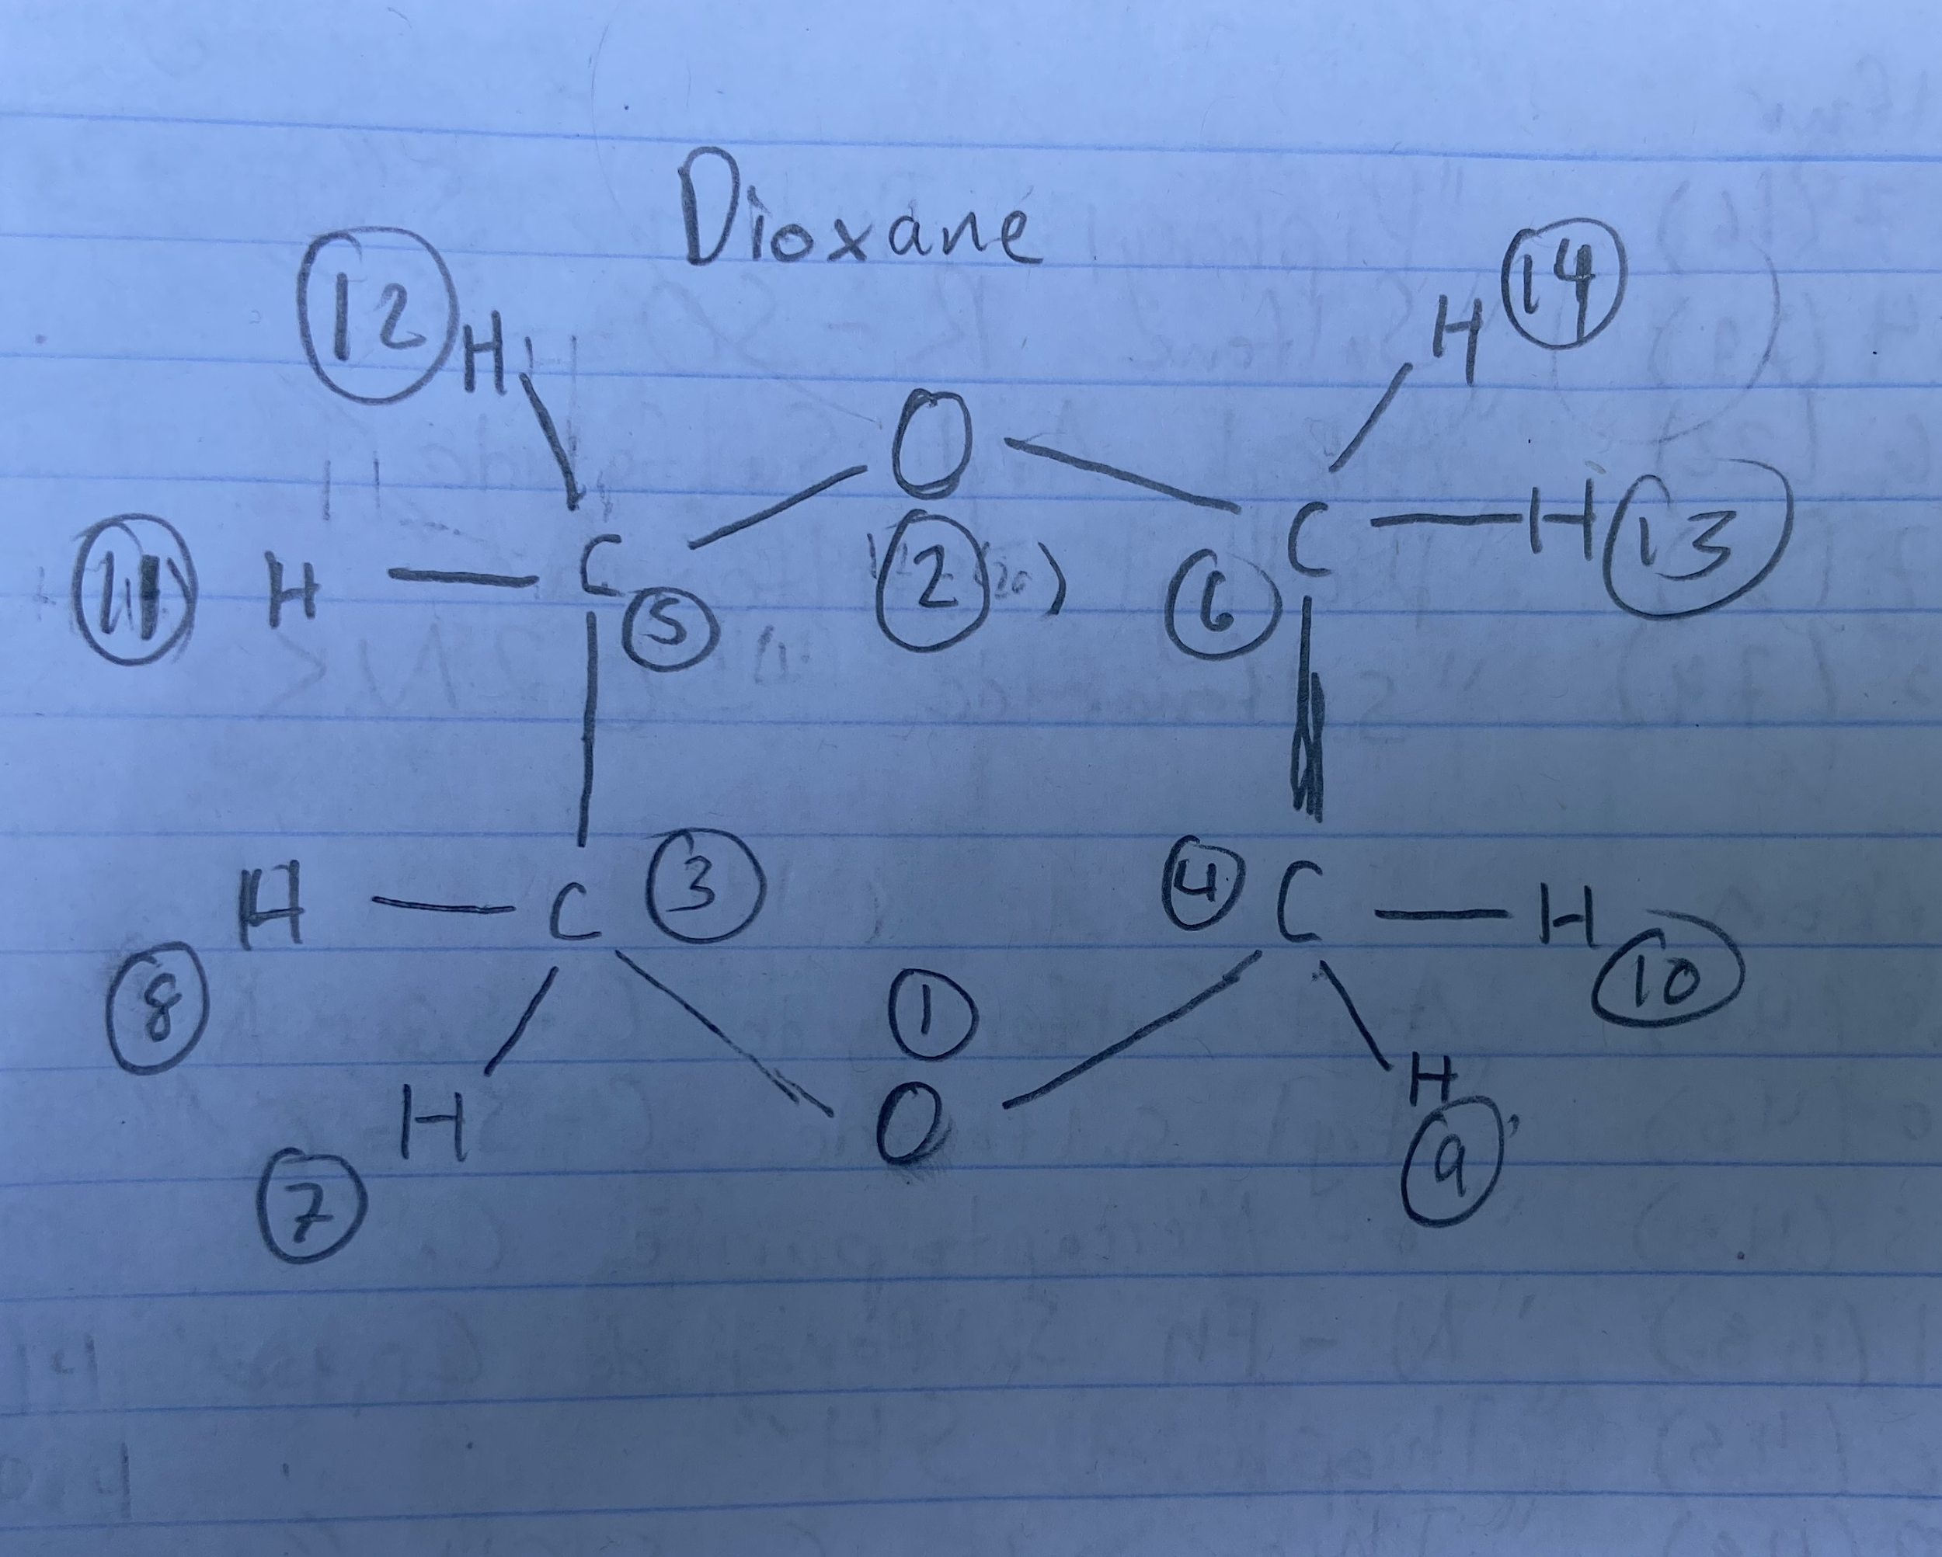

Resources used: Pubchem, Avogadro, general internet (Wikipedia and Google)

Parameters from <https://dasher.wustl.edu/tinker/distribution/params/oplsaa.prm> and converted to proper units (look at simazine file in triazine folder for conversion equations)

Categorization: Despite its ring structure, this structure does not exhibit aromatic qualities, and therefore must be developed around ethers. Both oxygens have alkanes on both sides and therefore are dialkyl ethers, while the carbons are part of an ethyl chain. The hydrogens are part of alkyl ethers

Bonds: nothing irregular

Angles: nothing irregular

Dihedrals: The unique dihedral #46-13-20-13 can be approximated to its wildcard dihedral #46-13-20-0

Impropers: no improper dihedrals

Density simulations: Dioxane’s reported density according to Pubchem is 1.03337 at 293 degrees kelvin. It’s melting point is well below 298, and therefore, the revised standard form for the density simulations (increase, then decrease temperature) is not applicable for this compound. Still, we needed a way to force the molecules to arrange themselves in a compact manner in the second and all subsequent control files, which we normally achieve by raising the temperature so that the compound is in a liquid state in which the fluidity of the state allows the molecules to more easily arrange themselves in a compact manner. Since the compound is already in a liquid state, the only way to increase the fluidity and make the box more compact is to depressurize the box at an extremely high rate,which Professor Bourg recommended to be 100 100 100.0. This was done for some time in the second control file, and then in the third control file, we decreased that rate to 10 10 10.0. Finally, the box is equilibrated at a 1 1 1.0 rate. Each of these control files ran for 200 thousand units of time, however, in the fourth and final file, the system crashed at 90 thousand units. However, the oscillations were already occurring around an average value of 1.00, and that average value is close enough to the reported value. Therefore, this confirms the reliability of the model contained in the lj file and no further simulations are required.